clc; %clearing the screen
clear; %clearing the variables
close all; %closing all the previous windows
x1 = randi([0,9],1,randi(10));%generating the 1st sequence randomly
x2 = randi([0,9],1,randi(10));%generating the 2nd sequence randomly
subplot(2,3,1); %1st subplot
stem(x1,'filled'); %discrete values of n length
xlabel('time');
ylabel('amplitude');
title('1st sequence'); %raw input sequence 1
subplot(2,3,2); %2nd subplot
stem(x2,'filled'); %discrete values of n length
xlabel('time');
ylabel('amplitude');
title('2nd sequence'); %raw input sequence 2
clin = conv(x1,x2);
subplot(2,3,3); %2nd subplot
stem(clin,'filled'); %discrete values of n length
xlabel('time');
ylabel('amplitude');
title('Linear Convolution of x1 and x2'); %Linear Convolution
ccirc = cconv(x1,x2);
subplot(2,3,4); %2nd subplot
stem(ccirc,'filled'); %discrete values of n length
xlabel('time');
ylabel('amplitude');
title('Circular Convolution of x1 and x2'); %Circular Convolution
n1 = length(x1); %length of the sequence
n2 = length(x2); %length of the sequence
n = max(n1,n2); % to have same length
if n1~=n2
x1 = [x1, zeros(1,n-n1)]; %add zeros if needed
x2 = [x2, zeros(1,n-n2)]; %add zeros if needed
end
ccirc1 = cconv(x1,x2,n1+n2-1);
subplot(2,3,5); %2nd subplot
stem(ccirc1,'filled'); %discrete values of n length
xlabel('time');
ylabel('amplitude');
title('Linear convolution using Circular Convolution '); %Circular Convolution
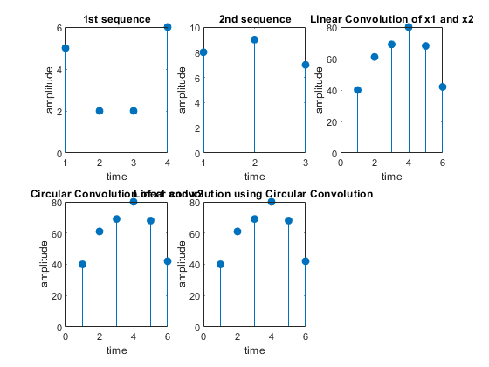
Published with MATLAB® R2020b

